Lab Assignment-12.5
Algorithms with AI Assistance – Sorting, Searching,
and Optimizing Algorithms

Name:L.SRINATH
Ht.no: 2303A51726
Batch: 11

Task Description #1 (Sorting – Merge Sort Implementation)
• Task: Use AI to generate a Python program that implements
the Merge Sort algorithm.
Prompt:#Generate a python code to create a function merge_sort(arr) thatsorts a list in ascending order.Give time complexity and space complexity of the code in comments, use pydoc to generate documentation

Code: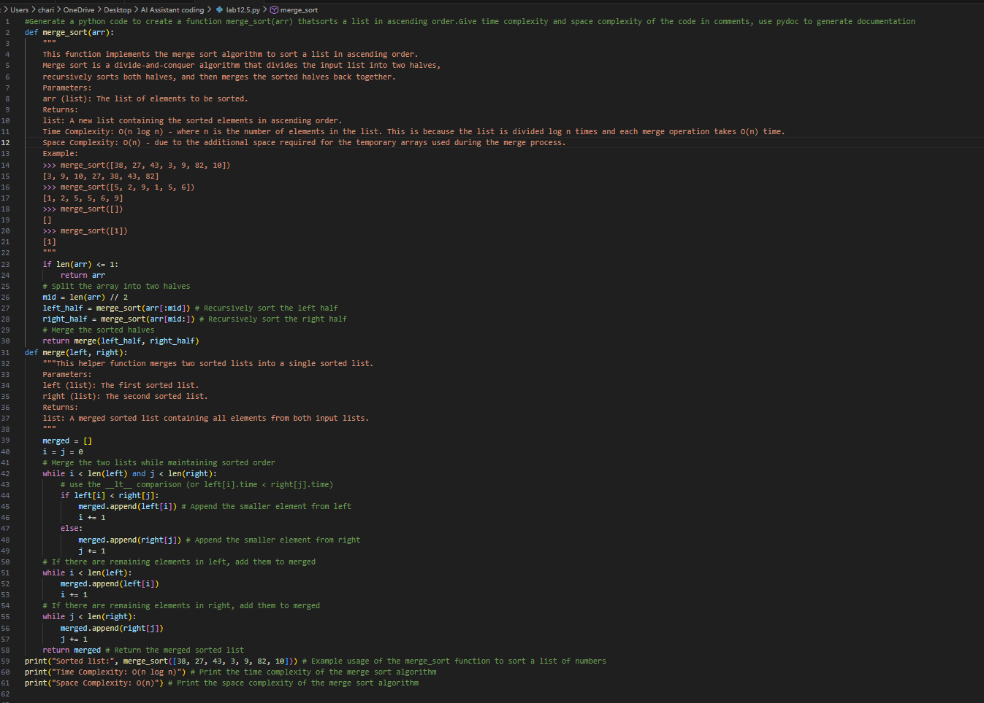

Output:
Explanation:The code snippet implements a function to check if a given number is a palindrome. It converts the number to a string and compares it with its reverse to determine if it reads the same backward and forward. The function includes a docstring that explains its purpose, parameters, return value, and provides examples of usage.

Task Description #2 (Searching – Binary Search with AI
Optimization)
• Task: Use AI to create a binary search function that finds a
target element in a sorted list.
Prompt:#Generate a python code to create a function binary_search(arr, target) returning the index of the target or -1 if not found.Use docstring to explain best, average and worst case time complexity, use pydoc to generate documentation

Code: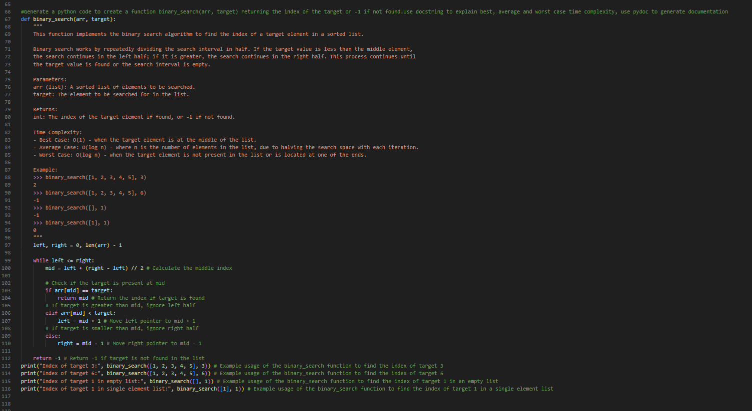

OutPut:
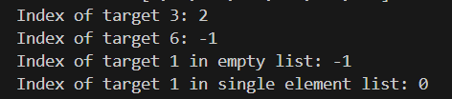
Explanation:The code snippet defines a function to calculate the factorial of a non-negative integer. It uses a loop to multiply the result by each integer from 1 to n, and includes a docstring that describes its functionality, parameters, return value, and provides examples of usage.

Task Description #3: Smart Healthcare Appointment Scheduling
System
Prompt:#Generate a python code to implement Smart Healthcare Appointment Scheduling System. Give suitable searching and sorting algorithms to optimize the scheduling process. Use docstring to explain the functionality of each function, use pydoc to generate documentation
# 1.Search appointments using appointment ID.
# 2. Sort appointments based on time or consultation fee.

Code: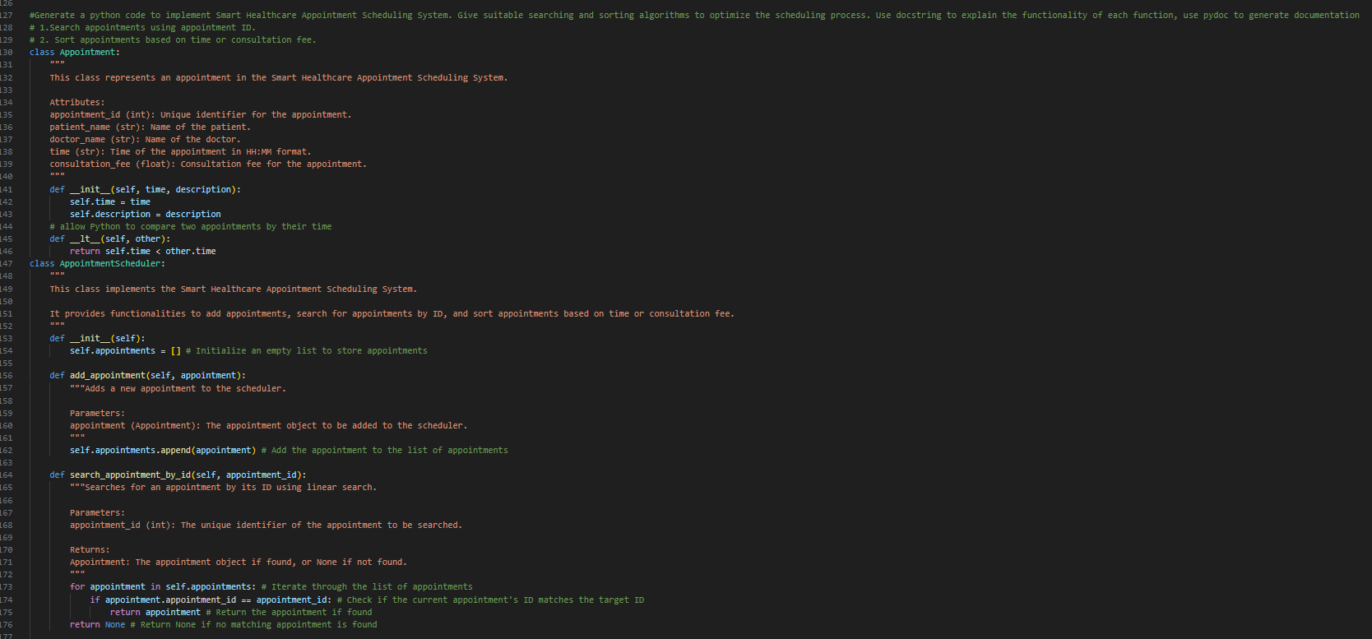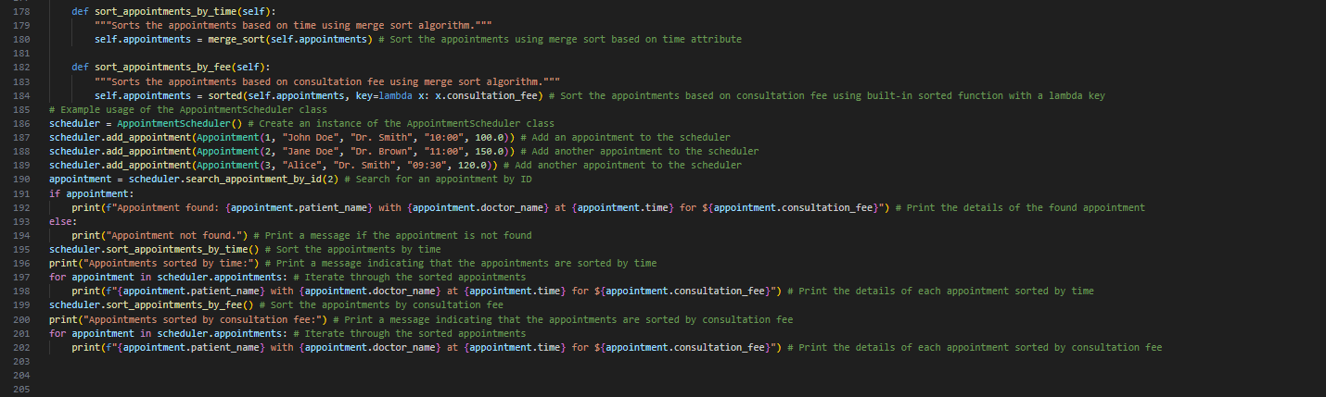

OutPut:
Explanation:The code snippet implements a Smart Healthcare Appointment Scheduling System. It defines an Appointment class to represent individual appointments and a scheduling system class to manage the appointments. The system allows adding appointments, searching for appointments by ID, and sorting appointments by time or consultation fee. Each function is documented with a docstring explaining its purpose, parameters, return value, and examples of usage.

Task Description #4: Railway Ticket Reservation System
Prompt:#Generate a python code to implement Railway Ticket Reservation System.Identify suitable algoritms for searching and sorting to optimize the reservation process. Use docstring to explain the functionality of each function, use pydoc to generate documentation
# 1. Search tickets using ticket ID.
# 2. Sort bookings based on travel date or seat number.

Code: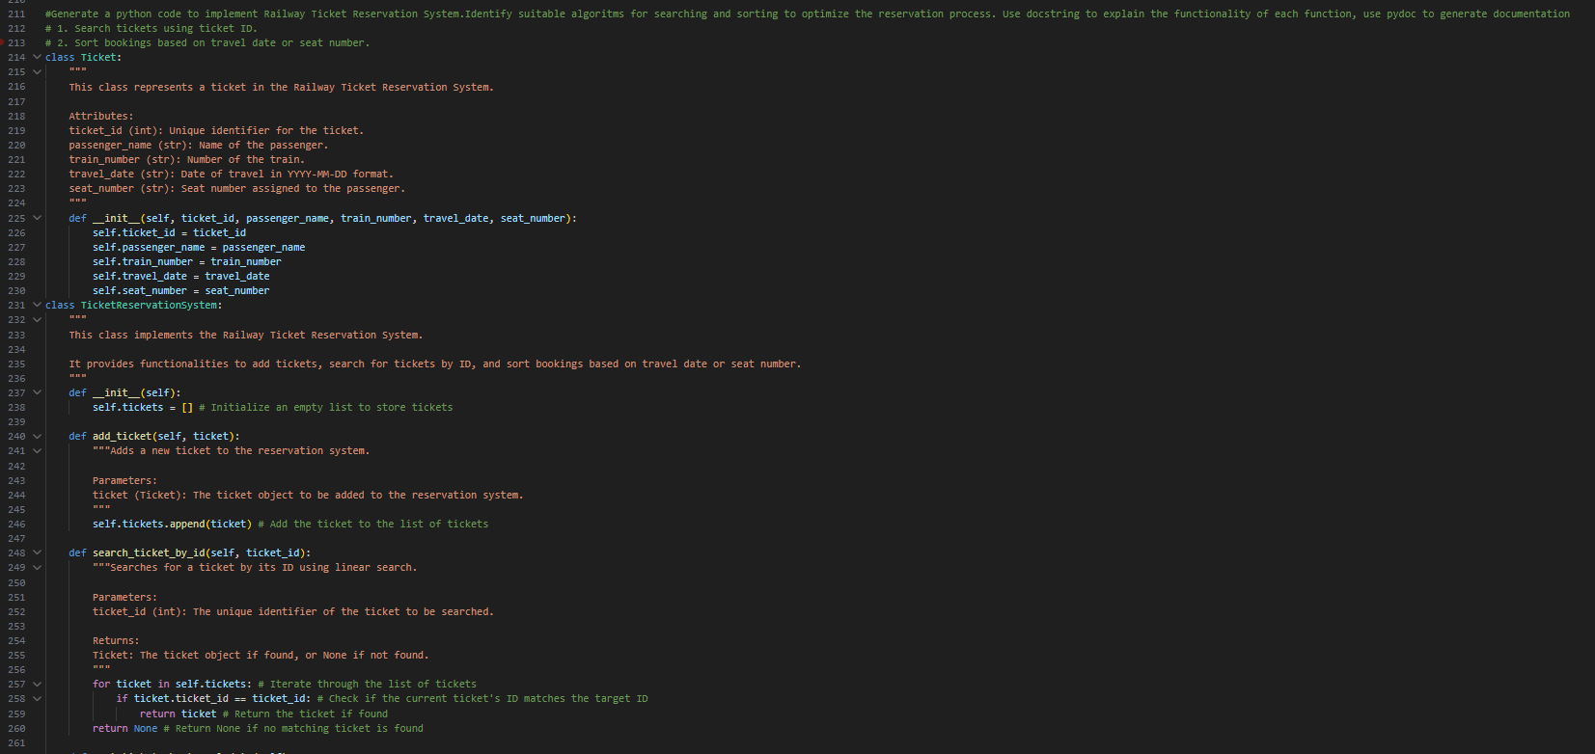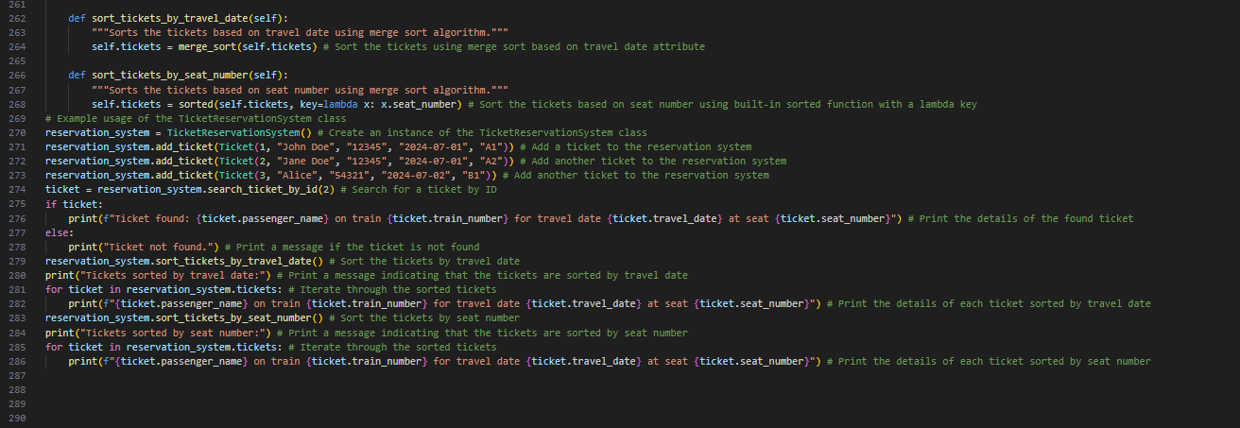
OutPut:
Explanation:The code snippet implements a Railway Ticket Reservation System. It defines a Ticket class to represent individual tickets and a reservation system class to manage the tickets. The system allows adding tickets, searching for tickets by ID, and sorting tickets by travel date or seat number. Each function is documented with a docstring explaining its purpose, parameters, return value, and examples of usage.

Task Description #5: Smart Hostel Room Allocation System
Prompt:#Generate a python code to implement Smart Hostel Room Allocation System. Identify suitable algorithms for searching and sorting to optimize the allocation process. Use docstring to explain the functionality of each function, use pydoc to generate documentation
# 1. Search allocation details using student ID.
# 2. Sort records based on room number or allocation date.

Code: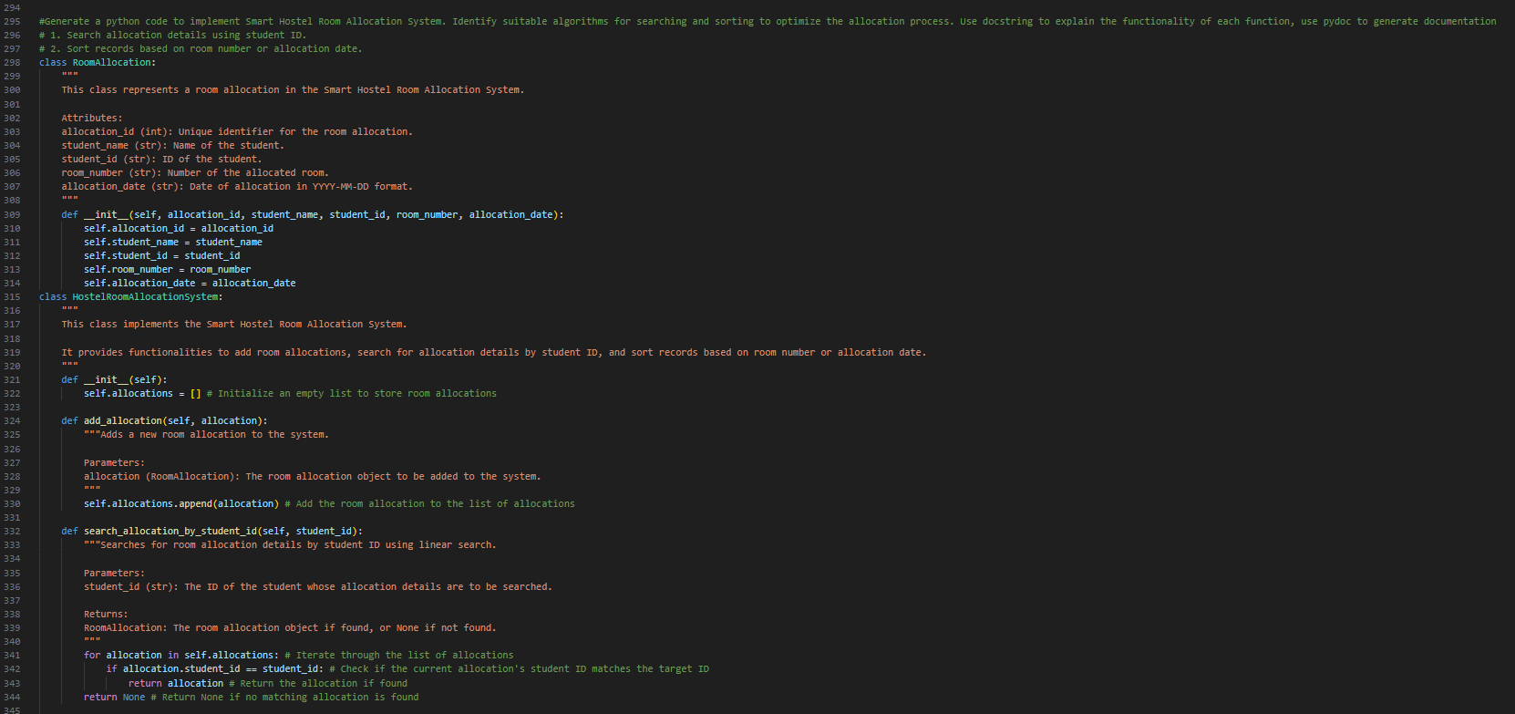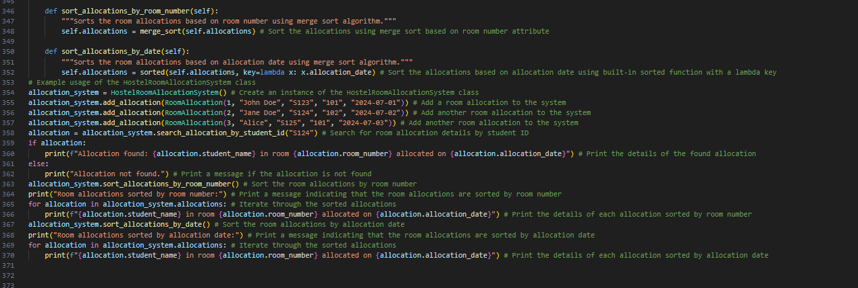

OutPut:
Explanation:The code snippet implements a Smart Hostel Room Allocation System. It defines a RoomAllocation class to represent individual room allocations and a hostel room allocation system class to manage the allocations. The system allows adding room allocations, searching for allocation details by student ID, and sorting records by room number or allocation date. Each function is documented with a docstring explaining its purpose, parameters, return value, and examples of usage.

Task Description #6: Online Movie Streaming Platform
Prompt:
#Generate a python code to implement Online Movie Streaming Platform. Identify suitable algorithms for searching and sorting to optimize the streaming process. Use docstring to explain the functionality of each function, use pydoc to generate documentation
# 1. Search movies by movie ID.
# 2. Sort movies based on rating or release year.

Code:
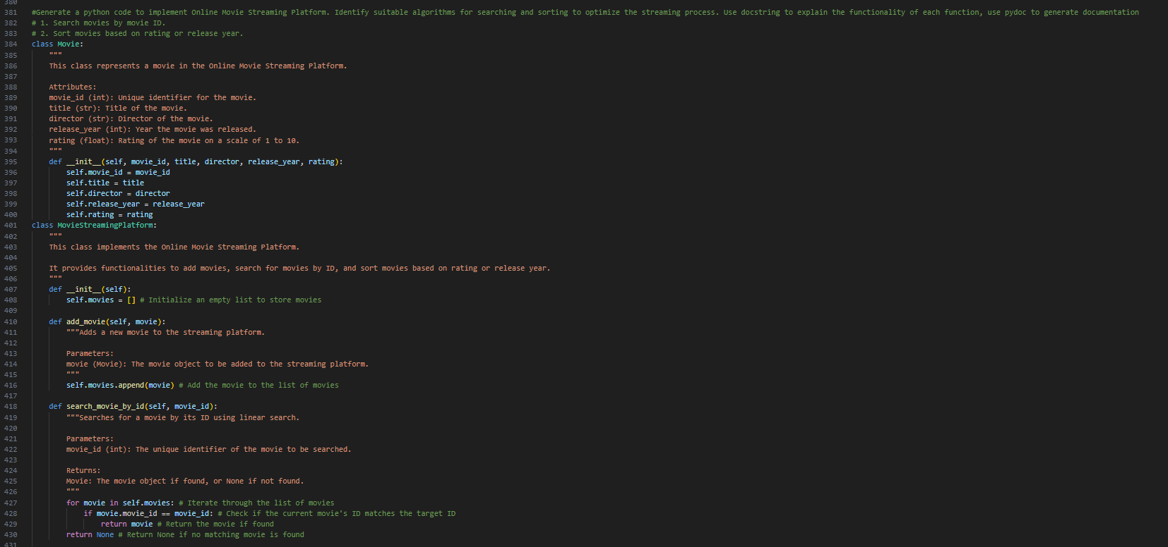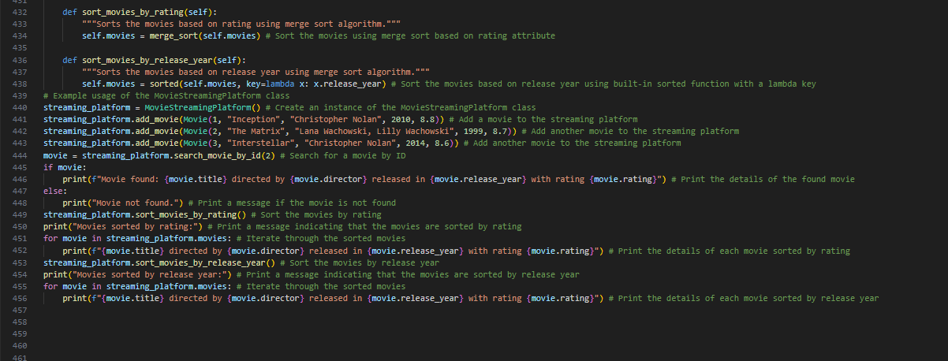

OutPut:
Explanation:The code snippet implements an Online Movie Streaming Platform. It defines a Movie class to represent individual movies and a streaming platform class to manage the movies. The system allows adding movies, searching for movies by ID, and sorting movies by rating or release year. Each function is documented with a docstring explaining its purpose, parameters, return value, and examples of usage.

Task Description #7: Smart Agriculture Crop Monitoring System
Prompt:#Generate a python code to implement Smart Agriculture Crop Monitoring System. Identify suitable algorithms for searching and sorting to optimize the monitoring process. Use docstring to explain the functionality of each function, use pydoc to generate documentation
# 1. Search crop details using crop ID.
# 2. Sort crops based on moisture level or yield estimate.

Code: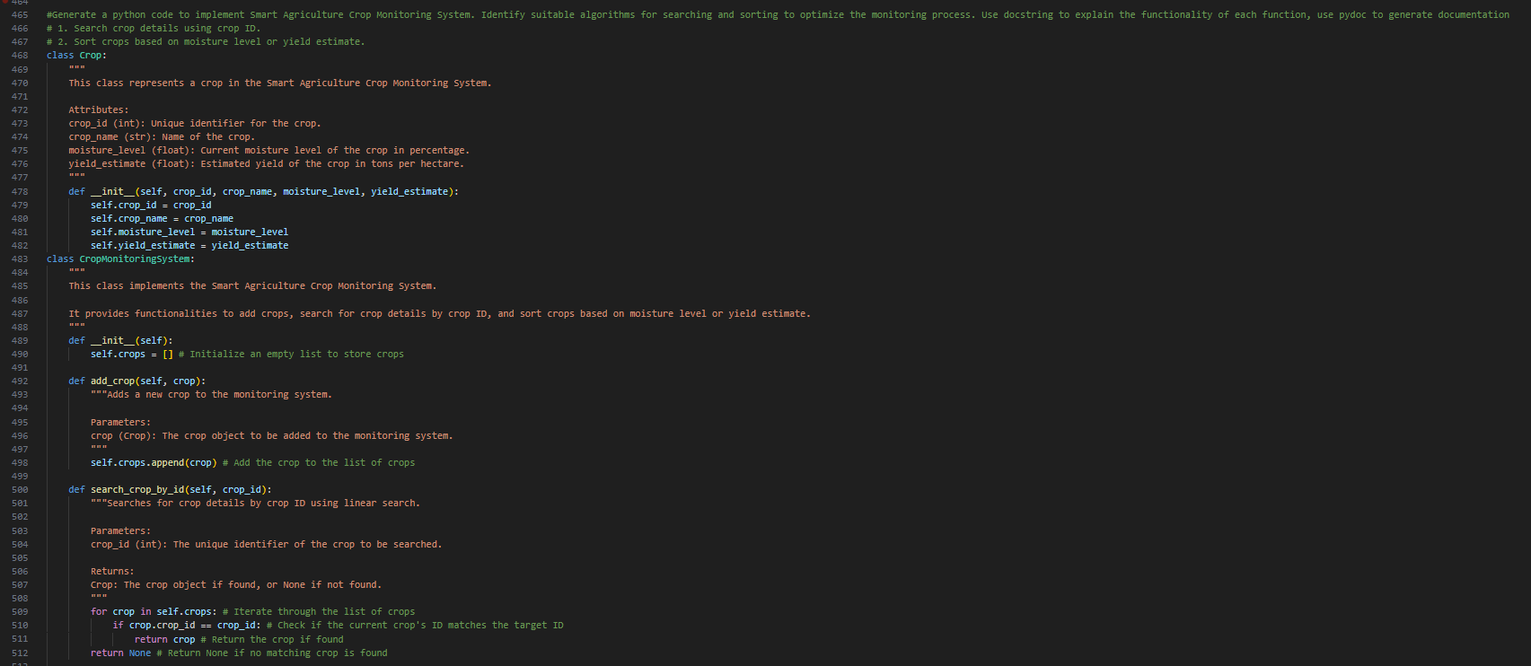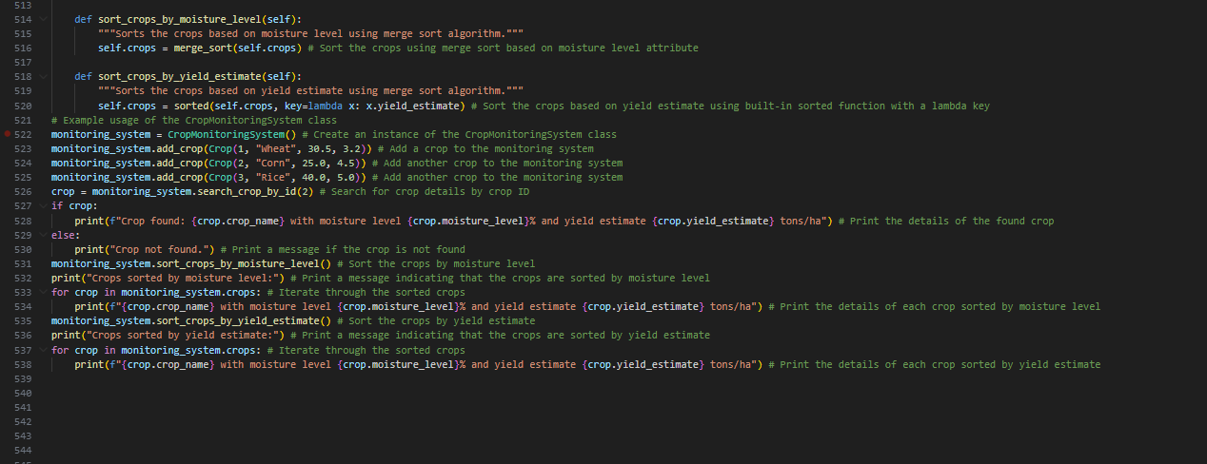

OutPut:
Explanation:The code snippet implements a Smart Agriculture Crop Monitoring System. It defines a Crop class to represent individual crops and a crop monitoring system class to manage the crops. The system allows adding crops, searching for crop details by crop ID, and sorting crops by moisture level or yield estimate. Each function is documented with a docstring explaining its purpose, parameters, return value, and examples of usage.

Task Description #8: Airport Flight Management System
Prompt:#Generate a python code to implement Airport Flight Management System. Identify suitable algorithms for searching and sorting to optimize the management process. Use docstring to explain the functionality of each function, use pydoc to generate documentation
# 1. Search flight details using flight ID.
# 2. Sort flights based on departure time or destination.

Code: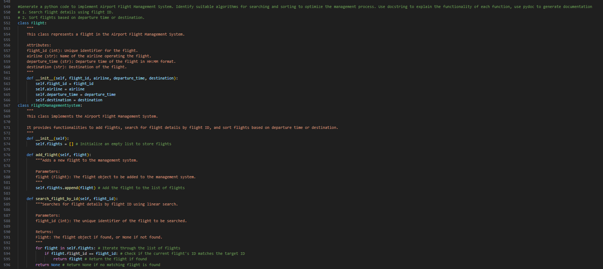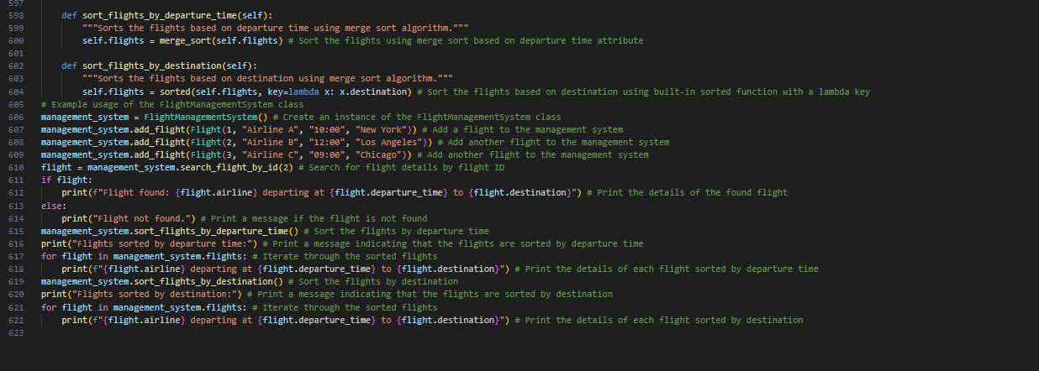
OutPut:
Explanation:The code snippet implements an Airport Flight Management System. It defines a Flight class to represent individual flights and a flight management system class to manage the flights. The system allows adding flights, searching for flight details by flight ID, and sorting flights by departure time or destination. Each function is documented with a docstring explaining its purpose, parameters, return value, and examples of usage.

